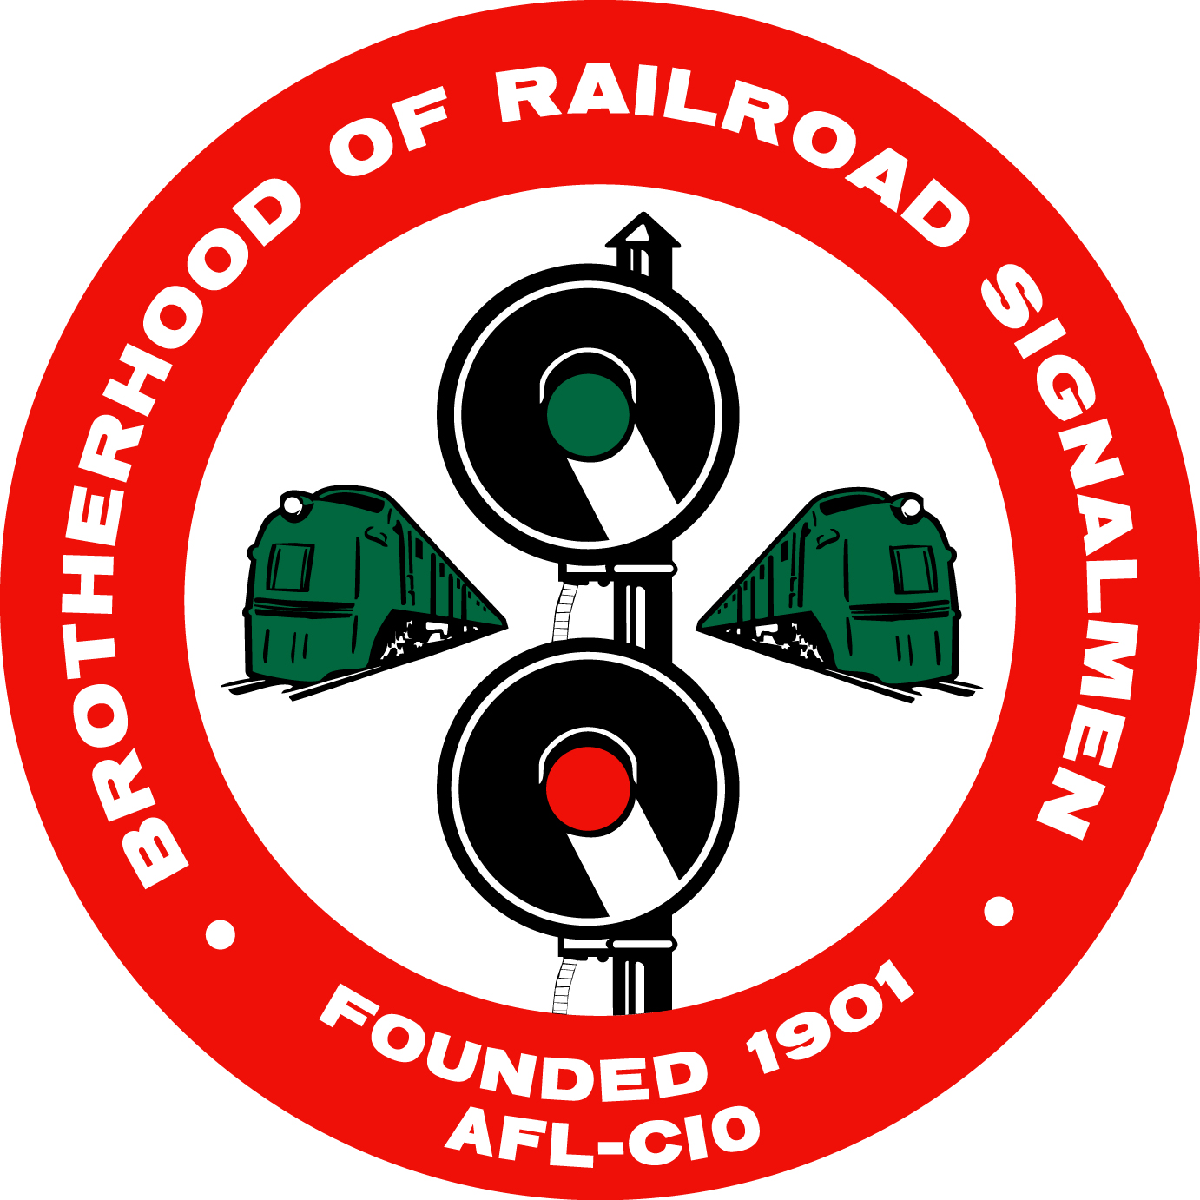
BROTHERHOOD OF RAILROAD SIGNALMEN
917 SHENANDOAH SHORES ROAD • FRONT ROYAL, VA 22630
(540) 622-6522• FAX (540) 622-6532

ATTENTION: Mike S. Baldwin — Secretary Treasurer

CONFIRMATION OF ATTENDANCE
— LOCAL FINANCIAL SECRETARY’S TRAINING CLASSES —
Front Royal, VA — Training begins at 9:00 a.m.

Name ________________________________________________________________

Address ______________________________________________________________

City, State, Zip _________________________________________________________

Title, Local ____________________________________________________________

Contact Phone Number___________________________ Shirt Size________________

This is to confirm that I plan to attend the Local Financial Secretary Training Class in Front Royal, Virginia, on _________________________________________

Please mail, fax, or email your confirmation to: Michaela Claywell at michaela@brs.org

