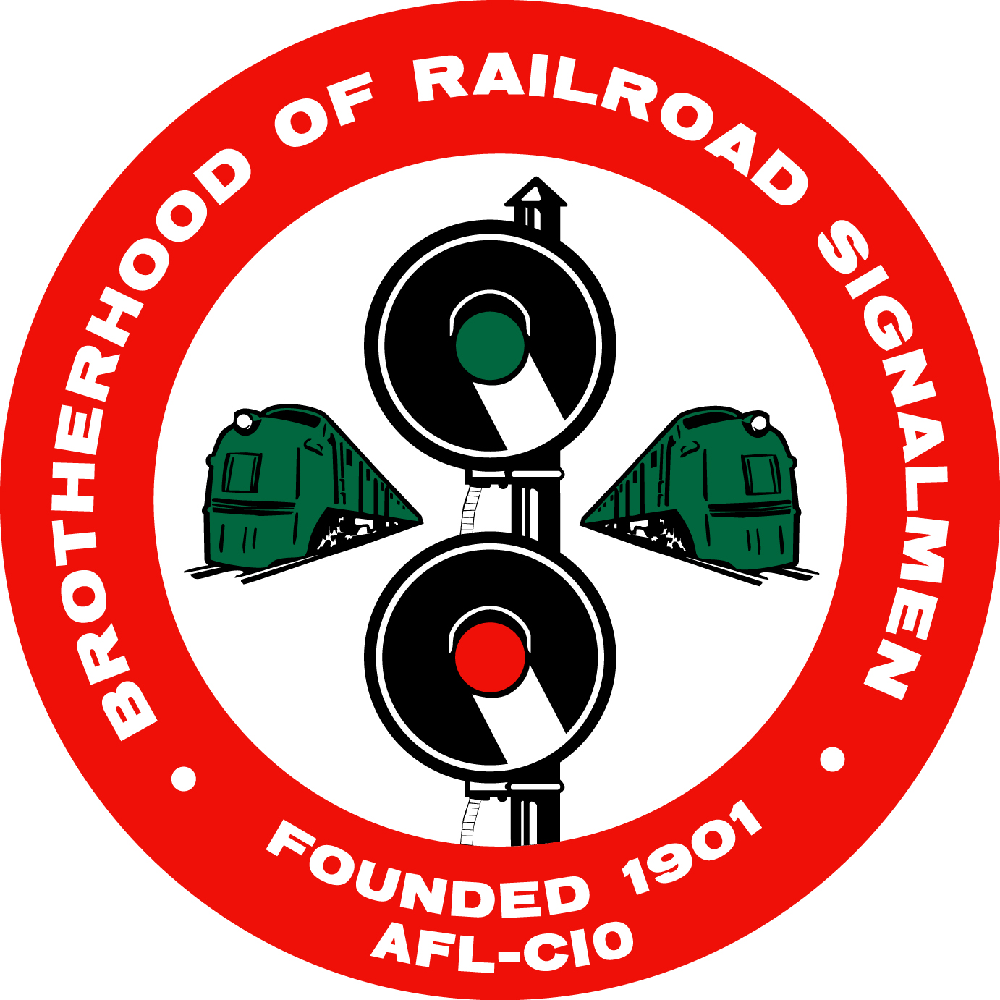
BROTHERHOOD OF RAILROAD SIGNALMEN
917 SHENANDOAH SHORES ROAD • FRONT ROYAL, VA 22630
(540) 622-6522• FAX (540) 622-6532

ATTENTION: Brandon Elvey— Vice President NRAB

CONFIRMATION OF ATTENDANCE
— LOCAL CHAIRMEN’S TRAINING CLASSES —
Front Royal, VA — Training begins at 9:00 a.m.

Name ________________________________________________________________

Address ______________________________________________________________

City, State, Zip _________________________________________________________

Title, Local ____________________________________________________________

Contact Phone Number___________________________ Shirt Size________________

This is to confirm that I plan to attend the Local Chairmen’s Training Class
in Front Royal, Virginia, on ______________________________________________

Please mail, fax, or email your confirmation to: whitney@brs.org

